Computer Networks
Lab 02
Syed Huzaifa Ali (23K-0004)
BAI-6A

Task 01:

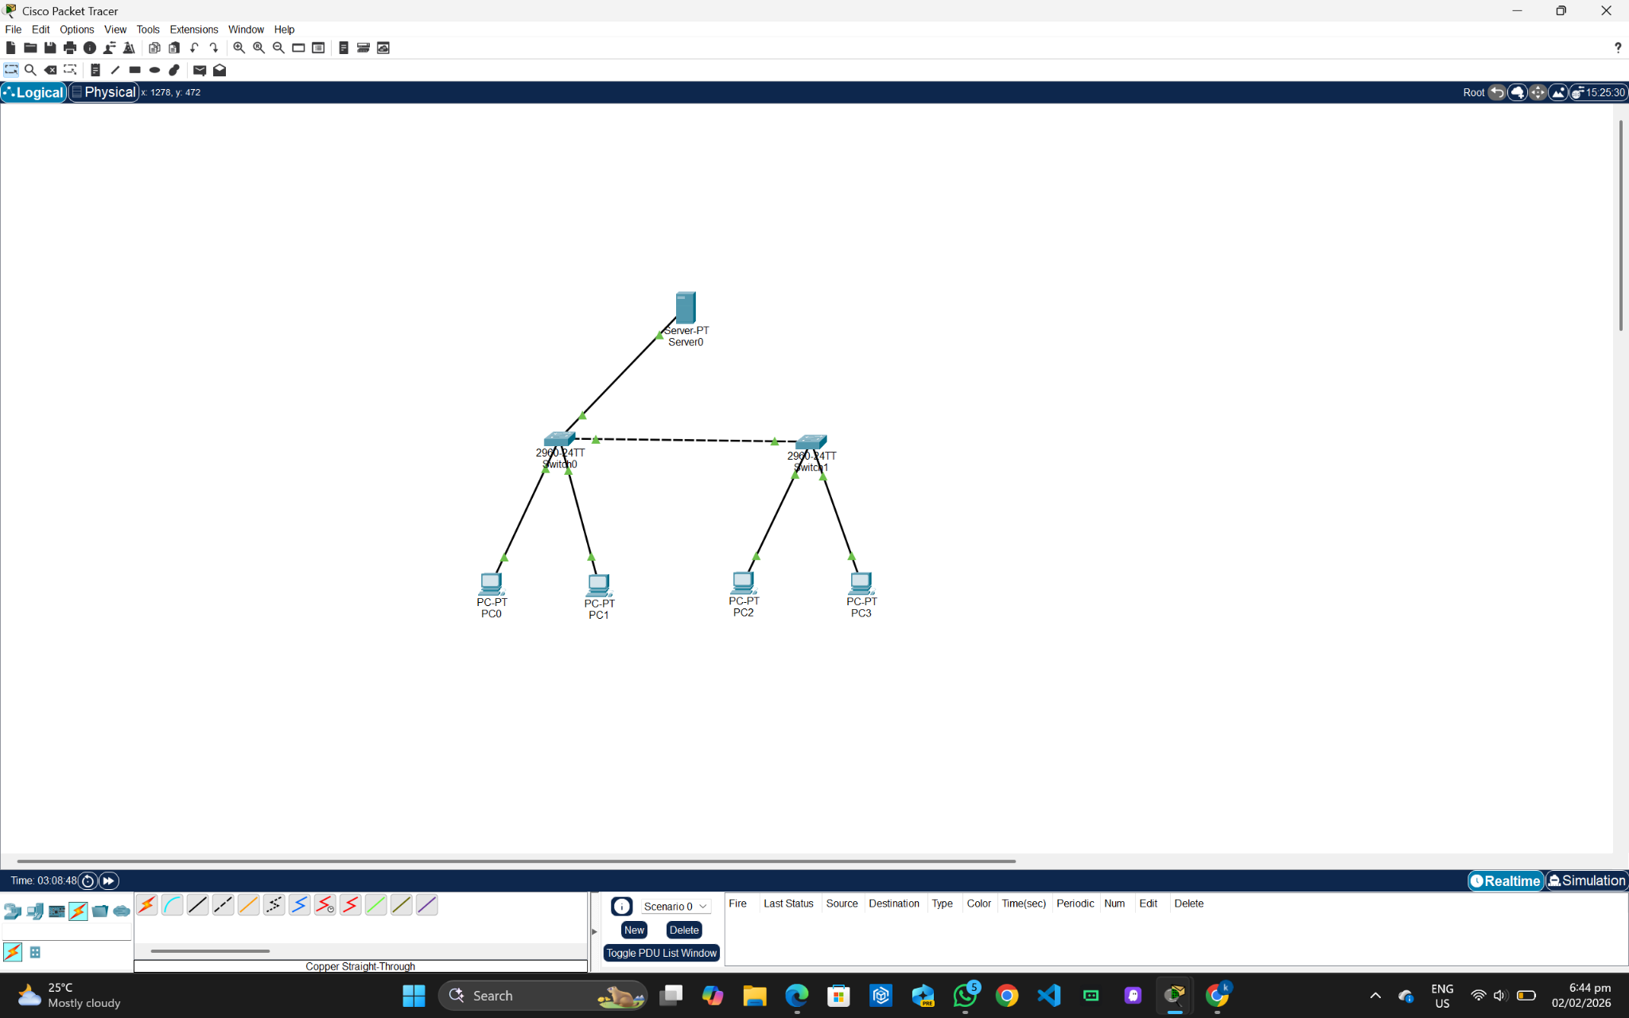

Connectivity using PC0:
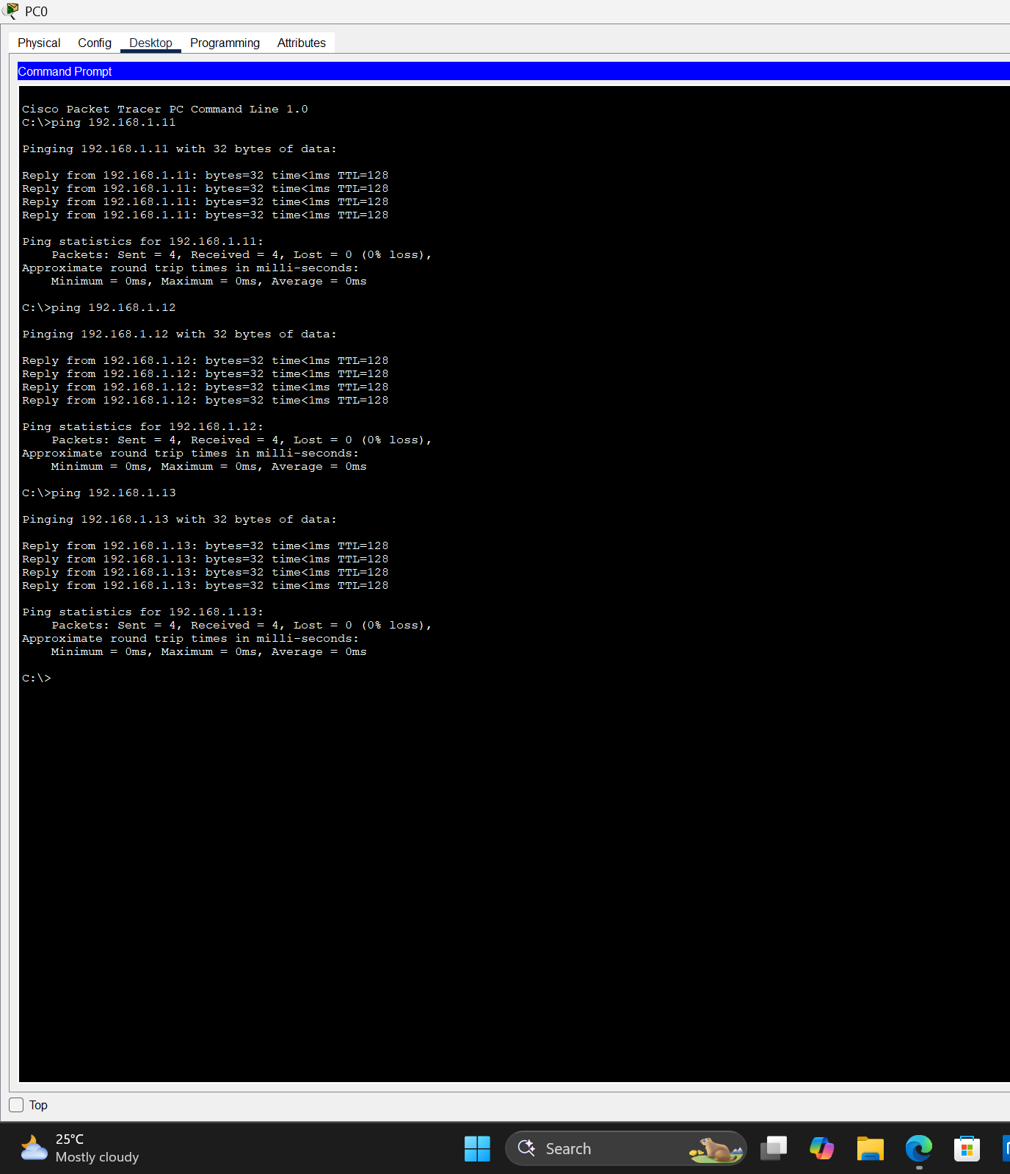

Inbound PDU details (ARP):
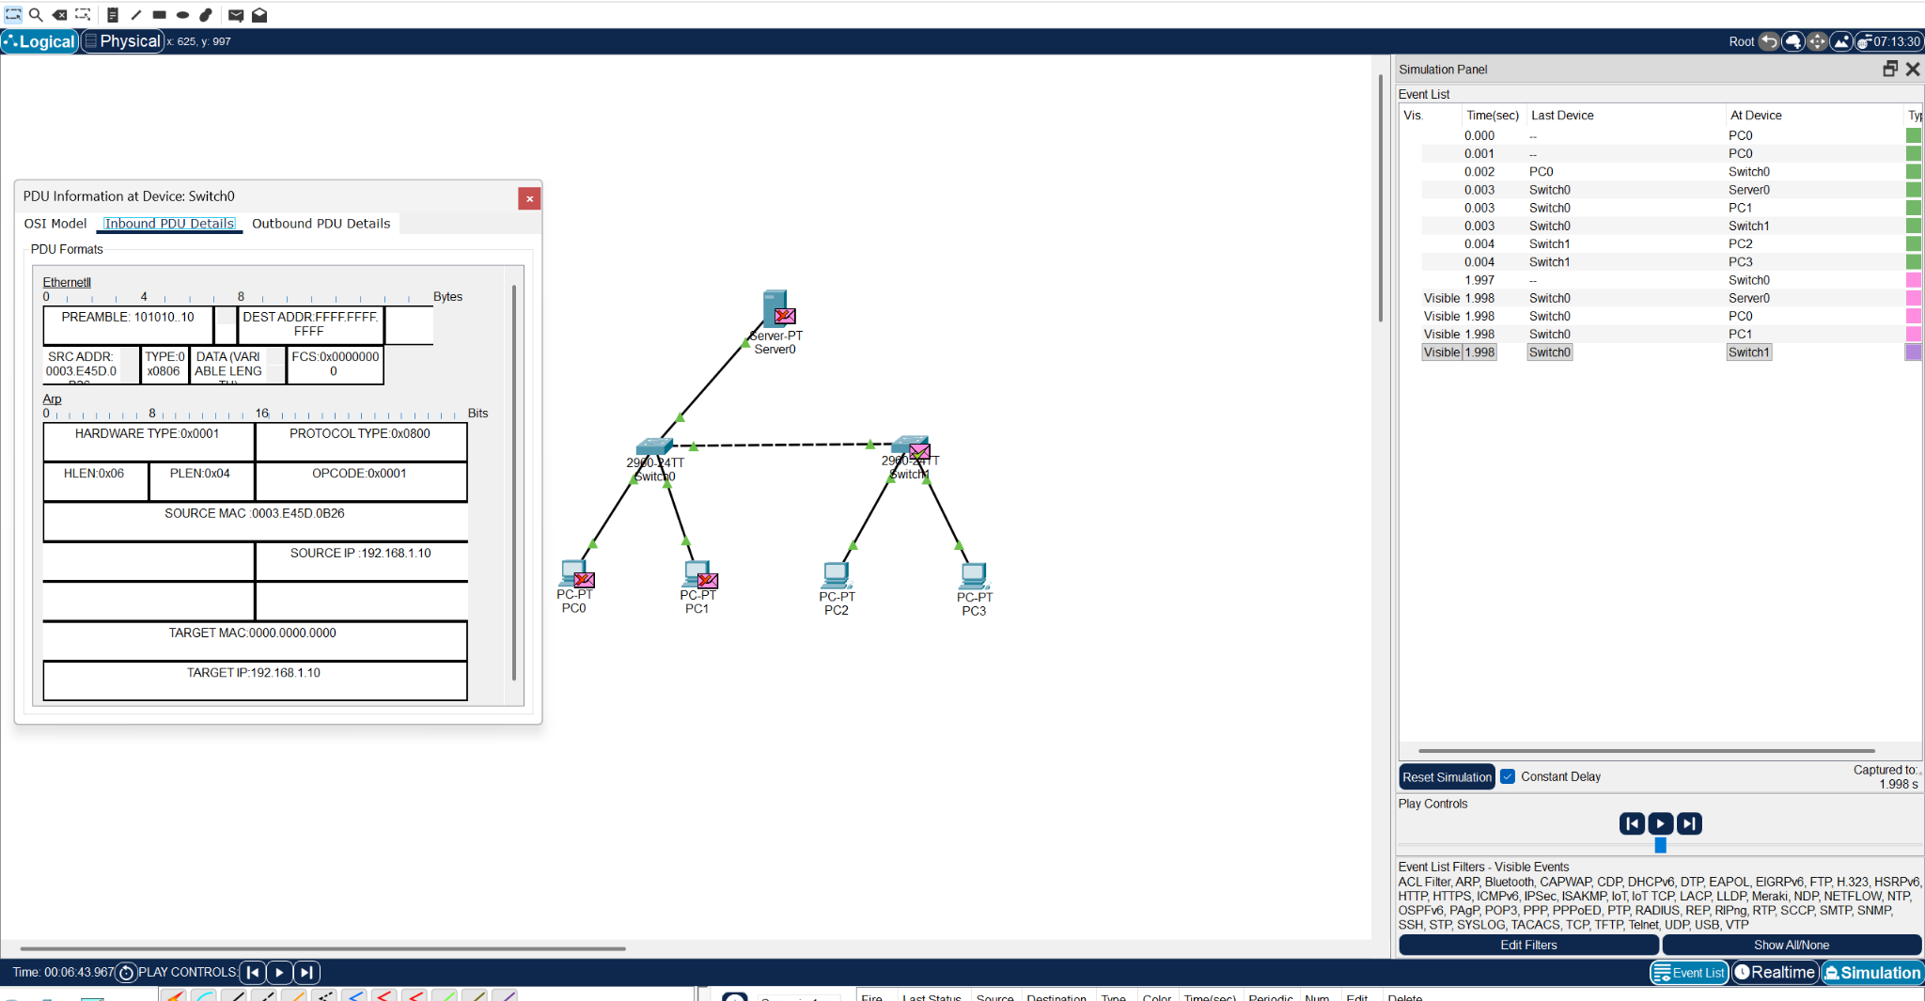

Outbound PDU details (ARP):
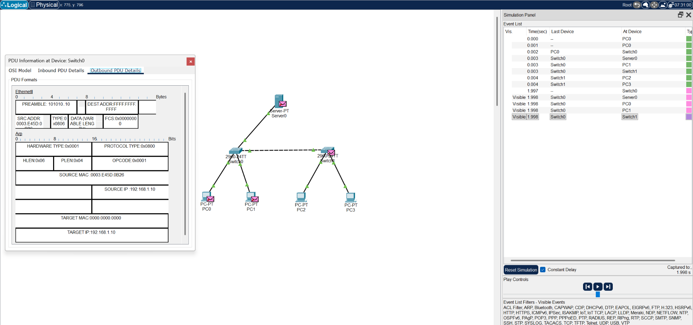

Functionalities:

PC:
- Act as end-user devices in the network.
- Generate and receive data traffic.
Switch:
- Provide interconnection between multiple devices in the same LAN.
Server:
- Acts as a centralized service provider in the network.

Task 02:

Switch:
- Switches connect devices to a singular LAN to transmit data from one device to another.
- It can operate on half-duplex and full duplex communication.
Hub:
- Hubs group Ethernet devices on a LAN, broadcasting all data to all devices.
- It can operate on half-duplex communication.

Task 03:

Segment 1: Console Cable should be used because the PC is connected to the console port.

Segment 2: Straight-through Cable because different types of devices are connected together.

Segment 3: Crossover Cable because, same types of devices are connected together.

Task 04:

This network uses two hubs and one bridge. Each hub connects four devices and forms one broadcast domain. The hub broadcasts all incoming data to every connected device.
The bridge connects the two hubs. It learns MAC addresses and forwards frames only when the destination is on the other hub. If the destination is on the same hub, the bridge blocks the frame.

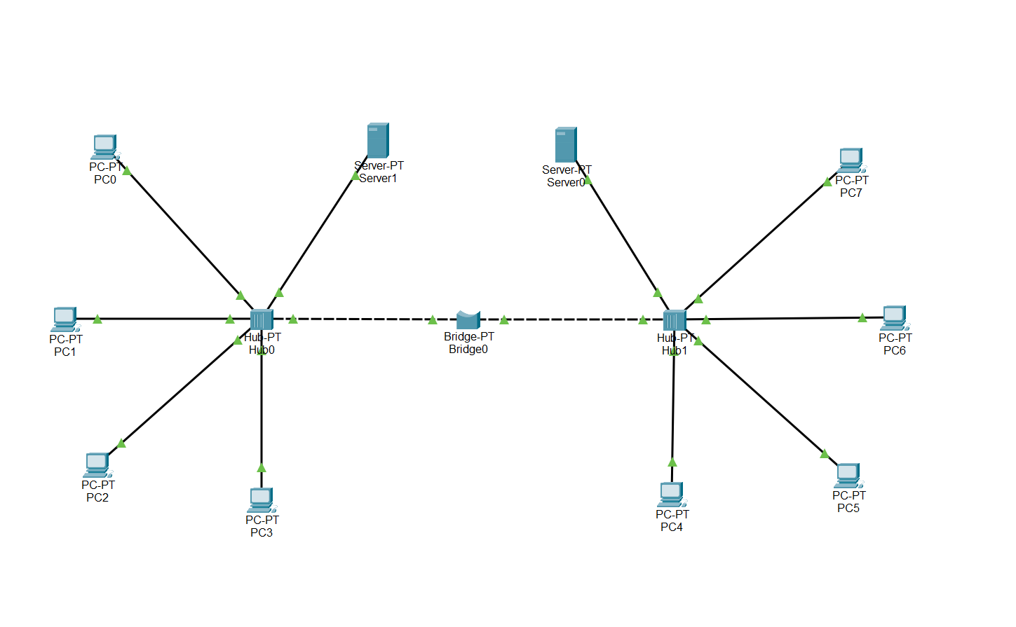

Checking connectivity:

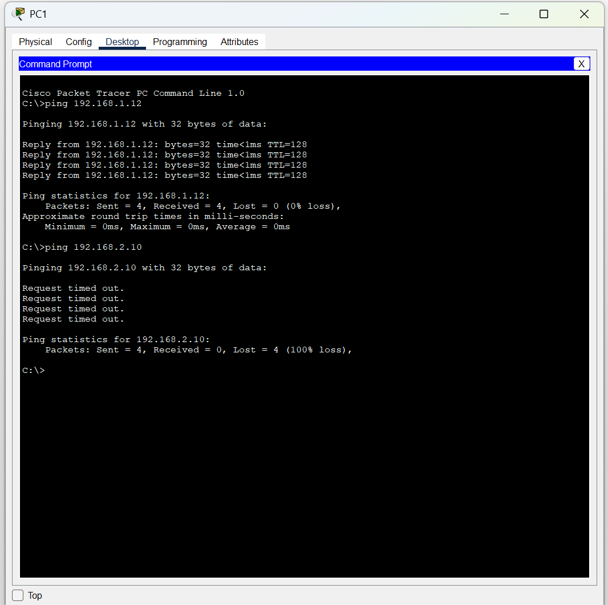

Simulation of data packet transfer:

